

Project Report On

**RAJANI JEWELLERS**

BY:

**VINEET LULLA (153130)**

**BHAVESH PUNJABI (153139)**

**NIKHIL RAJANI (153162)**

GUIDED BY:

**MR. D. V. CHAWAK**

Department of Computer Technology

Smt S. H. Mansukhani

Institute of Technology, Ulhasnagar-421003

Academic year : 2015-2016

Certificate

*This is to certify that _______________________________________ ,the students of third year of the course computer technology have completed project on building a* ***“WEBSITE”*** *on topic* ***“RAJANI JEWELLERS****.****”*** *in the academic year 2015-2016.*

*As a partial fulfilment of the diploma course in engineering/technology prescribed by Maharashtra State Board Of Technical Education(MSBTE),Mumbai For Academic Year 2015-2016*

*The following group made the project and each member of the group contributed equally in the development of the project.*

**VINEET LULLA (153130)**

**BHAVESH PUNJABI (153139)**

**NIKHIL RAJANI (153162)**

*And I have accessed the said work and I am satisfied that the same is up to the standard envisaged for the level of course.*

*And, said work may be presented to the external examiner.*

Date: _____________________ ________________________

(Signature of Guide)

__________________________ ________________________

(Head of Department) (Principal)

____________________________ ________________________

(Internal Examiner) (External Examiner)

**CONTENTS**

|  |  |
| --- | --- |
| SR NO. | TITLE |
| 1.  1.1  1.2  1.3  1.4 | Website  Introduction  Purpose  Features  Working System |
| 2. | Advantages of Project |
| 3.  3.1  3.2  3.3  3.4 | Project Plan  Website design  System Requirements  System Testing  Maintenance |
| 4.  4.1  4.2 | Need Of ASP.NET LANGUAGE  Overview of ASP.NET  Introduction To Microsoft Visual Studio |
| 5. | Future Enhancements |
| 6. | Coding And Screen Shots |
| 7. | Data Flow Diagrams |
| 8. | Conclusion |
| 9. | Bibliography / References |

CHAPTER 1

Introduction

This website solves the basic need of jewellery to the people.

This website is developed in ASP.NET language. In this website all the problems related to purchasing of jewellery is solved. Different types of jewellery are categorized into different accordingly.

In this website we have a feature which displays the daily rate of gold. Every day that module gets updated automatically when connected to internet.

**PURPOSE:-**

1. Provide all types of jewellery at one place.

2. Displaying each and every detail of the product.

3. Time saving

4. Saving of paper material

5. Labour work reduction

6. The major service is to provide best service to the customer

**Features:-**

1. Interactive GUI

2. Categories with pictures

3. Useful summary view

4. Everything at one place

5. Providing each and every detail of the product

6. Simple to understand

Products like:-Rings, Pendants, Earrings, Bracelets

**Working:-**

Working of present system:-

In this website all the jewellery products are updated. The owner of this website gives the necessary details to the developer of this website who updates this website with the latest products and the regarding details.

The website is updated according to the customers’ requirements.

Website is updated weekly or can be monthly.

New products are updated at the home page itself. Advertisements of the upcoming products are also displayed on our website.

**CHAPTER 2:-**

**Advantages of the project:-**

**Manual control:-**

This is manually controlled website.

Everything is updated by the developer and nothing is done automatically.

The pricing of the products are perfect and verified by the owner and then gets updated.

**User friendly:-**

* This website is a very user friendly website.
* Everything the user needs is present and easily available.
* It is not a complex website because the products are categorised accordingly.

Development is easy:-

* The language used for this website is a simple language.
* The website is easy to handle.
* Updating is easy.

**CHAPTER 3:-**

**PROJECT PLAN**

**Website Design:-**

**ASP.NET** is an [open-source](https://en.wikipedia.org/wiki/Open_source)[server-side](https://en.wikipedia.org/wiki/Server-side_scripting) [web application framework](https://en.wikipedia.org/wiki/Web_application_framework) designed for [web development](https://en.wikipedia.org/wiki/Web_development) to produce [dynamic web pages](https://en.wikipedia.org/wiki/Dynamic_web_page). It was developed by [Microsoft](https://en.wikipedia.org/wiki/Microsoft) to allow [programmers](https://en.wikipedia.org/wiki/Programmer) to build dynamic [web sites](https://en.wikipedia.org/wiki/Web_site), [web applications](https://en.wikipedia.org/wiki/Web_application) and [web services](https://en.wikipedia.org/wiki/Web_service).

It was first released in January 2002 with version 1.0 of the [.NET Framework](https://en.wikipedia.org/wiki/.NET_Framework), and is the successor to Microsoft's [Active Server Pages](https://en.wikipedia.org/wiki/Active_Server_Pages) (ASP) technology. ASP.NET is built on the [Common Language Runtime](https://en.wikipedia.org/wiki/Common_Language_Runtime) (CLR), allowing programmers to write ASP.NET code using any supported[.NET language](https://en.wikipedia.org/wiki/List_of_CLI_languages). The ASP.NET [SOAP](https://en.wikipedia.org/wiki/SOAP) extension framework allows ASP.NET components to process SOAP messages.

ASP.NET is in the process of being re-implemented as a modern and modular [web framework](https://en.wikipedia.org/wiki/Web_framework), together with other frameworks like [Entity Framework](https://en.wikipedia.org/wiki/Entity_Framework). The new framework will make use of the new open-source [.NET Compiler Platform](https://en.wikipedia.org/wiki/.NET_Compiler_Platform) (code-name "Roslyn") and be [cross platform](https://en.wikipedia.org/wiki/Cross_platform). [ASP.NET MVC](https://en.wikipedia.org/wiki/ASP.NET_MVC), ASP.NET Web API, and ASP.NET Web Pages (a platform using only [Razor](https://en.wikipedia.org/wiki/ASP.NET_Razor) pages) will merge into a unified MVC 6. The project is called [ASP.NET vNext](https://en.wikipedia.org/wiki/ASP.NET_vNext).

**Characteristics:-**

ASP.NET Web pages, known officially as Web Forms, are the main building blocks for application development in ASP.NET. There are two basic methodologies for Web Forms, a web application format and a web site format. Web applications need to be compiled before deployment, while web sites structures allows the user to copy the files directly to the server without prior compilation. Web forms are contained in files with a ".aspx" extension; these files typically contain static ([X](https://en.wikipedia.org/wiki/XHTML))[HTML](https://en.wikipedia.org/wiki/HTML)markup or component markup. The component markup can include server-side Web Controls and User Controls that have been defined in the framework or the web page. For example, there is a textbox component which can be defined on a page as<asp:textbox id='myid' runat='server'> which will be rendered into a html input box. Additionally, dynamic code, which runs on the server, can be placed in a page within a block <% -- dynamic code -- %>, which is similar to other Web development technologies such as [PHP](https://en.wikipedia.org/wiki/PHP), [JSP](https://en.wikipedia.org/wiki/JavaServer_Pages), and [ASP](https://en.wikipedia.org/wiki/Active_Server_Pages).

With [ASP.NET Framework 2.0](https://en.wikipedia.org/wiki/ASP.NET_3.5), Microsoft introduced a new *code-behind* model which allows static text to remain on the .aspx page, while dynamic code remains in an .aspx.vb or .aspx.cs or .aspx.fs file (depending on the programming language used).

**System Requirements:-**

**Software Requirements:-**

1. Microsoft Windows XP/2007/2008

2. Microsoft Visual Studio 2010

**Hardware Requirements:-**

1. Hard Disk Drive:10gb and above.

2. Ram:-1GB and above

3. Internal Pentium Processor:-133mhz or higher.

**System Testing:-**

In this phase we have tested the project that we created. It basically sees the logical internals and externals of the software.

It took around 7 days to complete the testing of the project because after completing the project we showed it to our guide and he told us to make some changes in the project.

Our guide also suggested us to add some more modules to our project .

So after making all the changes we gave it to our guide to complete the testing part.

**Maintainence:-**

Software maintenance replies each of the preceeding life cycle steps to an existing program.

In maintenance part there are also we have done the various steps for maintaining it properly so that it does not require any extra maintaining part.

**CHAPTER 4:-**

**NEED OF ASP.NET LANGUAGE**

**Overview of ASP.NET:-**

ASP.NET aims for performance benefits over other script-based technologies (including classic ASP) by compiling the server-side code the first time it is used to one or more [DLL](https://en.wikipedia.org/wiki/Dynamic_link_library) [files](https://en.wikipedia.org/wiki/Computer_file) on the [Web server](https://en.wikipedia.org/wiki/Web_server).

These dll files or assemblies contain Microsoft Intermediate Language (MSIL) for running within the [common language runtime](https://en.wikipedia.org/wiki/Common_language_runtime); this provides a performance boost over pure scripted languages and is similar to the approach used by Python and not dissimilar to [Java Server Pages](https://en.wikipedia.org/wiki/JavaServer_Pages).

This compilation happens automatically the first time a page is requested (which means the developer need not perform a separate compilation step for pages).

This feature provides the ease of development offered by scripting languages with the performance benefits of a compiled binary.

However, the compilation might cause a noticeable but short delay to the Web user when the newly edited page is first requested from the Web server, but will not again unless the page requested is updated further.

The ASPX and other resource files are placed in a virtual host on an [Internet Information Services](https://en.wikipedia.org/wiki/Internet_Information_Services) server (or other compatible ASP.NET servers; see Other implementations, below).

The first time a client requests a page, the .NET Framework parses and compiles the file(s) into a .NET assembly and sends the response; subsequent requests are served from the DLL files.

By default ASP.NET will compile the entire site in batches of 1000 files upon first request.

If the compilation delay is causing problems, the batch size or the compilation strategy may be tweaked.

**Introduction to Microsoft Visual Studio:-**

**Microsoft Visual Studio** is an [integrated development environment](https://en.wikipedia.org/wiki/Integrated_development_environment) (IDE) from [Microsoft](https://en.wikipedia.org/wiki/Microsoft). It is used to develop [computer programs](https://en.wikipedia.org/wiki/Computer_program) for [Microsoft Windows](https://en.wikipedia.org/wiki/Microsoft_Windows), as well as [web sites](https://en.wikipedia.org/wiki/Web_site), [web applications](https://en.wikipedia.org/wiki/Web_application) and [web services](https://en.wikipedia.org/wiki/Web_service). Visual Studio uses Microsoft software development platforms such as [Windows API](https://en.wikipedia.org/wiki/Windows_API), [Windows Forms](https://en.wikipedia.org/wiki/Windows_Forms), [Windows Presentation Foundation](https://en.wikipedia.org/wiki/Windows_Presentation_Foundation), [Windows Store](https://en.wikipedia.org/wiki/Windows_Store) and [Microsoft Silver light](https://en.wikipedia.org/wiki/Microsoft_Silverlight). It can produce both [native code](https://en.wikipedia.org/wiki/Native_code) and managed.

Visual Studio includes a [code editor](https://en.wikipedia.org/wiki/Code_editor) supporting [IntelliSense](https://en.wikipedia.org/wiki/IntelliSense) (the [code completion](https://en.wikipedia.org/wiki/Code_completion) component) as well as [code refactoring](https://en.wikipedia.org/wiki/Code_refactoring). The integrated [debugger](https://en.wikipedia.org/wiki/Microsoft_Visual_Studio_Debugger) works both as a source-level debugger and a machine-level debugger. Other built-in tools include a forms designer for building [GUI](https://en.wikipedia.org/wiki/GUI) applications, [web designer](https://en.wikipedia.org/wiki/Web_designer), [class](https://en.wikipedia.org/wiki/Class_(computing)) designer, and [database schema](https://en.wikipedia.org/wiki/Database_schema) designer. It accepts plug-ins that enhance the functionality at almost every level—including adding support for [source-control](https://en.wikipedia.org/wiki/Source_control) systems (like [Subversion](https://en.wikipedia.org/wiki/Subversion_(software))) and adding new toolsets like editors and visual designers for [domain-specific languages](https://en.wikipedia.org/wiki/Domain-specific_language) or toolsets for other aspects of the [software development lifecycle](https://en.wikipedia.org/wiki/Software_development_lifecycle) (like the [Team Foundation Server](https://en.wikipedia.org/wiki/Team_Foundation_Server) client: Team Explorer).

Visual Studio supports different [programming languages](https://en.wikipedia.org/wiki/Programming_language) and allows the code editor and debugger to support (to varying degrees) nearly any programming language, provided a language-specific service exists. Built-in languages include [C](https://en.wikipedia.org/wiki/C_(programming_language)), [C++](https://en.wikipedia.org/wiki/C%2B%2B) and [C++/CLI](https://en.wikipedia.org/wiki/C%2B%2B/CLI) (via [Visual C++](https://en.wikipedia.org/wiki/Visual_C%2B%2B)), [VB.NET](https://en.wikipedia.org/wiki/VB.NET) (via [Visual Basic .NET](https://en.wikipedia.org/wiki/Visual_Basic_.NET)), [C#](https://en.wikipedia.org/wiki/C_Sharp_(programming_language)) (via [Visual C#](https://en.wikipedia.org/wiki/Visual_C_Sharp)), and [F#](https://en.wikipedia.org/wiki/F_Sharp_(programming_language)) (as of Visual Studio 2010). Support for other languages such as [M](https://en.wikipedia.org/wiki/MUMPS), [Python](https://en.wikipedia.org/wiki/IronPython), and [Ruby](https://en.wikipedia.org/wiki/IronRuby) among others is available via language services installed separately. It also

supports [XML](https://en.wikipedia.org/wiki/XML)/[XSLT](https://en.wikipedia.org/wiki/XSLT), [HTML](https://en.wikipedia.org/wiki/HTML)/[XHTML](https://en.wikipedia.org/wiki/XHTML), [JavaScript](https://en.wikipedia.org/wiki/JavaScript) and[CSS](https://en.wikipedia.org/wiki/Cascading_Style_Sheets). Java (and J#) were supported in the past.

**Architecture:-**

Visual Studio does not support any programming language, solution or tool intrinsically; instead, it allows the plugging of functionality coded as a VS Package. When installed, the functionality is available as a *Service*. The IDE provides three services: SVs Solution, which provides the ability to enumerate projects and solutions; SVs UI Shell, which provides windowing and UI functionality (including tabs, toolbars and tool windows); and SVs Shell, which deals with registration of VS Packages. In addition, the IDE is also responsible for coordinating and enabling communication between services. All editors, designers, project types and other tools are implemented as VS Packages. Visual Studio uses [COM](https://en.wikipedia.org/wiki/Component_Object_Model) to access the VS Packages. The Visual Studio [SDK](https://en.wikipedia.org/wiki/Software_development_kit) also includes the *Managed Package Framework* (*MPF*), which is a set of [managed](https://en.wikipedia.org/wiki/Managed_code) wrappers around the COM-interfaces that allow the Packages to be written in any [CLI compliant language](https://en.wikipedia.org/wiki/List_of_CLI_languages). However, MPF does not provide all the functionality exposed by the Visual Studio COM interfaces. The services can then be consumed for creation of other packages, which add functionality to the Visual Studio IDE.

Support for programming languages is added by using a specific VS Package called a *Language Service*. A language service defines various interfaces which the VS Package implementation can implement to add support for various functionalities. Functionalities that can be added this way include syntax colouring, statement completion; brace matching, parameter information tooltips, member lists and error markers for background compilation. If the interface is implemented, the functionality will be available for the language. Language services are to be implemented on a per-language basis. The implementations can reuse code from the parser or the compiler for the language. Language services can be implemented either in [native code](https://en.wikipedia.org/wiki/Native_code) or [managed code](https://en.wikipedia.org/wiki/Managed_code). For native code, either the native COM interfaces or the Babel Framework (part of Visual Studio SDK) can be used. For managed code, the MPF includes wrappers for writing managed language services.

**Features:-**

**Code editor**

Like any other [IDE](https://en.wikipedia.org/wiki/Integrated_Development_Environment), it includes a [code editor](https://en.wikipedia.org/wiki/Code_editor) that supports [syntax highlighting](https://en.wikipedia.org/wiki/Syntax_highlighting) and [code completion](https://en.wikipedia.org/wiki/Autocomplete) using [IntelliSense](https://en.wikipedia.org/wiki/IntelliSense) for [variables](https://en.wikipedia.org/wiki/Variable_(programming)), [functions](https://en.wikipedia.org/wiki/Subroutine), [methods](https://en.wikipedia.org/wiki/Method_(computer_science)), [loops](https://en.wikipedia.org/wiki/Program_loops) and[LINQ](https://en.wikipedia.org/wiki/LINQ) queries. IntelliSense is supported for the included languages, as well as for [XML](https://en.wikipedia.org/wiki/XML) and for [Cascading Style Sheets](https://en.wikipedia.org/wiki/Cascading_Style_Sheets) and [JavaScript](https://en.wikipedia.org/wiki/JavaScript) when developing web sites and [web applications](https://en.wikipedia.org/wiki/Web_application).[[19]](https://en.wikipedia.org/wiki/Microsoft_Visual_Studio#cite_note-vs2008js-19)[[20]](https://en.wikipedia.org/wiki/Microsoft_Visual_Studio#cite_note-vs2008css-20) Auto complete suggestions appear in a [modeless](https://en.wikipedia.org/wiki/Modeless) [list box](https://en.wikipedia.org/wiki/List_box) over the code editor window, in proximity of the editing [cursor](https://en.wikipedia.org/wiki/Cursor_(computing)). In Visual Studio 2008 onwards, it can be made temporarily semi-transparent to see the code obstructed by it.[[18]](https://en.wikipedia.org/wiki/Microsoft_Visual_Studio#cite_note-vs2008editor-18) The code editor is used for all supported languages.

The Visual Studio code editor also supports setting bookmarks in code for quick navigation. Other navigational aids include [collapsing code blocks](https://en.wikipedia.org/wiki/Code_folding) and [incremental search](https://en.wikipedia.org/wiki/Incremental_search), in addition to normal text search and [regex](https://en.wikipedia.org/wiki/Regular_expression) search. The code editor also includes a multi-item [clipboard](https://en.wikipedia.org/wiki/Clipboard) and a task list.[[21]](https://en.wikipedia.org/wiki/Microsoft_Visual_Studio#cite_note-feat-21) The code editor supports code snippets, which are saved templates for repetitive code and can be inserted into code and customized for the project being worked on. A management tool for code snippets is built in as well. These tools are surfaced as floating windows which can be set to automatically hide when unused or docked to the side of the screen. The Visual Studio code editor also supports [code refactoring](https://en.wikipedia.org/wiki/Code_refactoring) including parameter reordering, variable and method renaming, [interface](https://en.wikipedia.org/wiki/Interface_(computing)) extraction and encapsulation of class members inside properties, among others.

Visual Studio features background compilation (also called incremental compilation). As code is being written, Visual Studio compiles it in the background in order to provide feedback about syntax and compilation errors, which are flagged with a red wavy underline. Warnings are marked with a green underline. Background compilation does not generate executable code, since it requires a different compiler than the one used to generate executable code. Background compilation was initially introduced with [Microsoft Visual Basic](https://en.wikipedia.org/wiki/Microsoft_Visual_Basic) but has now been expanded for all included languages.[[23]](https://en.wikipedia.org/wiki/Microsoft_Visual_Studio#cite_note-advbasics-23)

**Debugger**

*Main article:*[*Microsoft Visual Studio Debugger*](https://en.wikipedia.org/wiki/Microsoft_Visual_Studio_Debugger)

Visual Studio includes a [debugger](https://en.wikipedia.org/wiki/Debugger) that works both as a source-level debugger and as a machine-level debugger. It works with both [managed code](https://en.wikipedia.org/wiki/Managed_code) as well as [native code](https://en.wikipedia.org/wiki/Native_code) and can be used for debugging applications written in any language supported by Visual Studio. In addition, it can also attach to running processes and monitor and debug those processes. If source code for the running process is available, it displays the code as it is being run. If source code is not available, it can show the [disassembly](https://en.wikipedia.org/wiki/Disassembly). The Visual Studio debugger can also create [memory dumps](https://en.wikipedia.org/wiki/Memory_dump) as well as load them later for debugging. Multi-threaded programs are also supported. The debugger can be configured to be launched when an application running outside the Visual Studio environment crashes.

The debugger allows setting [breakpoints](https://en.wikipedia.org/wiki/Breakpoint) (which allow execution to be stopped temporarily at a certain position) and watches (which monitor the values of variables as the execution progresses). Breakpoints can be conditional, meaning they get triggered when the condition is met. Code can be [stepped over](https://en.wikipedia.org/wiki/Program_animation), i.e., run one line (of source code) at a time. It can either *step into* functions to debug inside it, or *step over* it, i.e., the execution of the function body isn't available for manual inspection. The debugger supports *Edit and Continue*, i.e., it allows code to be edited as it is being debugged. When debugging, if the mouse pointer hovers over any variable, its current value is displayed in a tooltip ("data tooltips"), where it can also be modified if desired. During coding, the Visual Studio debugger lets certain functions be invoked manually from the immediate tool window. The parameters to the method are supplied at the immediate window.[[29]](https://en.wikipedia.org/wiki/Microsoft_Visual_Studio#cite_note-29)

**Designer**

Visual Studio includes a host of visual designers to aid in the development of applications. These tools include:

**Windows Forms Designer**

The Windows Forms designer is used to build [GUI](https://en.wikipedia.org/wiki/GUI) applications using [Windows Forms](https://en.wikipedia.org/wiki/WinForms). Layout can be controlled by housing the controls inside other containers or locking them to the side of the form. Controls that display data (like textbox, list box, grid view, etc.) can be [bound](https://en.wikipedia.org/wiki/Data_binding) to data sources like [databases](https://en.wikipedia.org/wiki/Database) or [queries](https://en.wikipedia.org/wiki/LINQ). Data-bound controls can be created by dragging items from the Data Sources window onto a design surface.[[30]](https://en.wikipedia.org/wiki/Microsoft_Visual_Studio#cite_note-30) The UI is linked with code using an [event-driven programming](https://en.wikipedia.org/wiki/Event-driven_programming) model. The designer generates either [C#](https://en.wikipedia.org/wiki/C_Sharp_(programming_language)) or [VB.NET](https://en.wikipedia.org/wiki/VB.NET) code for the application.

**WPF Designer**

The WPF designer, codenamed *Cider*, was introduced with Visual Studio 2008. Like the Windows Forms designer it supports the drag and drop metaphor. It is used to author [user interfaces](https://en.wikipedia.org/wiki/User_interface) targeting [Windows Presentation Foundation](https://en.wikipedia.org/wiki/Windows_Presentation_Foundation). It supports all WPF functionality including [data binding](https://en.wikipedia.org/wiki/Data_binding) and automatic layout management. It generates [XAML](https://en.wikipedia.org/wiki/XAML) code for the UI. The generated [XAML](https://en.wikipedia.org/wiki/XAML) file is compatible with [Microsoft Expression Design](https://en.wikipedia.org/wiki/Microsoft_Expression_Design), the designer-oriented product. The XAML code is linked with code using a [code-behind](https://en.wikipedia.org/wiki/Code-behind) model.

**Web designer/development**

Visual Studio also includes a web-site editor and designer that allows web pages to be authored by dragging and dropping widgets. It is used for developing[ASP.NET](https://en.wikipedia.org/wiki/ASP.NET) applications and supports [HTML](https://en.wikipedia.org/wiki/HTML), [CSS](https://en.wikipedia.org/wiki/CSS) and [JavaScript](https://en.wikipedia.org/wiki/JavaScript). It uses a [code-behind](https://en.wikipedia.org/wiki/Code-behind) model to link with ASP.NET code. From Visual Studio 2008 onwards, the layout engine used by the web designer is shared with [Microsoft Expression Web](https://en.wikipedia.org/wiki/Microsoft_Expression_Web). There is also [ASP.NET MVC](https://en.wikipedia.org/wiki/ASP.NET_MVC) support for [MVC](https://en.wikipedia.org/wiki/Model%E2%80%93view%E2%80%93controller) technology as a separate download and [ASP.NET Dynamic Data](https://en.wikipedia.org/wiki/ASP.NET_Dynamic_Data) project available from Microsoft.

**Class designer**

The Class Designer is used to author and edit the classes (including its members and their access) using [UML](https://en.wikipedia.org/wiki/Unified_Modeling_Language) modeling. The Class Designer can generate [C#](https://en.wikipedia.org/wiki/C_Sharp_(programming_language))and [VB.NET](https://en.wikipedia.org/wiki/VB.NET) code outlines for the classes and methods. It can also generate class diagrams from hand-written classes.

**Data designer**

The data designer can be used to graphically edit [database schemas](https://en.wikipedia.org/wiki/Database_schema), including typed tables, primary and foreign keys and constraints. It can also be used to design queries from the graphical view.

**Mapping designer**

From Visual Studio 2008 onwards, the mapping designer is used by [LINQ to SQL](https://en.wikipedia.org/wiki/Language_Integrated_Query) to design the [mapping](https://en.wikipedia.org/wiki/Object-Relational_mapping) between [database schemas](https://en.wikipedia.org/wiki/Database_schema) and the [classes](https://en.wikipedia.org/wiki/Class_(computing)) that encapsulate the data. The new solution from ORM approach, [ADO.NET Entity Framework](https://en.wikipedia.org/wiki/ADO.NET_Entity_Framework), replaces and improves the old technology.

**Other tools**

**Open Tabs Browser**

The open tabs browser is used to list all open tabs and to switch between them. It is invoked using CTRL+TAB.

**Properties Editor**

The *Properties Editor* tool is used to edit properties in a GUI pane inside Visual Studio. It lists all available properties (both read-only and those which can be set) for all objects including [classes](https://en.wikipedia.org/wiki/Class_(computing)), forms, web pages and other items.

**Object Browser**

The *Object Browser* is a [namespace](https://en.wikipedia.org/wiki/Namespace) and [class library](https://en.wikipedia.org/wiki/Class_library) browser for [Microsoft .NET](https://en.wikipedia.org/wiki/Microsoft_.NET). It can be used to browse the namespaces (which are arranged hierarchically) in [managed](https://en.wikipedia.org/wiki/Managed_code) [assemblies](https://en.wikipedia.org/wiki/Assembly_(CLI)). The hierarchy may or may not reflect the organization in the file system.

**Solution Explorer**

In Visual Studio parlance, a solution is a set of code files and other resources that are used to build an application. The files in a solution are arranged hierarchically, which might or might not reflect the organization in the file system. The *Solution Explorer* is used to manage and browse the files in a solution.

**Team Explorer**

*Team Explorer* is used to integrate the capabilities of [Team Foundation Server](https://en.wikipedia.org/wiki/Team_Foundation_Server), the [Revision Control System](https://en.wikipedia.org/wiki/Revision_Control_System) into the IDE (and the basis for Microsoft's [CodePlex](https://en.wikipedia.org/wiki/CodePlex)hosting environment for open source projects). In addition to source control it provides the ability to view and manage individual work items (including bugs, tasks and other documents) and to browse [TFS](https://en.wikipedia.org/wiki/Team_Foundation_Server) statistics. It is included as part of a TFS install and is also available as a download for Visual Studio separately. Team Explorer is also available as a stand-alone environment solely to access TFS services.

**Data Explorer**

*Data Explorer* is used to manage databases on [Microsoft SQL Server](https://en.wikipedia.org/wiki/Microsoft_SQL_Server) instances. It allows creation and alteration of database tables (either by issuing [T-SQL](https://en.wikipedia.org/wiki/T-SQL)commands or by using the Data designer). It can also be used to create [queries](https://en.wikipedia.org/wiki/Database_query) and [stored procedures](https://en.wikipedia.org/wiki/Stored_procedure), with the latter in either [T-SQL](https://en.wikipedia.org/wiki/T-SQL) or in [managed code](https://en.wikipedia.org/wiki/Managed_code) via[SQL CLR](https://en.wikipedia.org/wiki/SQL_CLR). Debugging and [IntelliSense](https://en.wikipedia.org/wiki/IntelliSense) support is available as well.

**Server Explorer**

The *Server Explorer* tool is used to manage database connections on an accessible computer. It is also used to browse running [Windows Services](https://en.wikipedia.org/wiki/Windows_Service), performance counters, [Windows Event Log](https://en.wikipedia.org/wiki/Windows_Event_Log) and [message queues](https://en.wikipedia.org/wiki/Message_queue) and use them as a data source.

**Dotfuscator Software Services Community Edition**

Visual Studio includes a free 'light' version of [Dotfuscator](https://en.wikipedia.org/wiki/Dotfuscator) by [Pre Emptive Solutions](https://en.wikipedia.org/wiki/PreEmptive_Solutions) which performs code obfuscation and application size reduction. Starting with Visual Studio 2010, this version of Dotfuscator includes [runtime intelligence](https://en.wikipedia.org/wiki/Runtime_intelligence) capabilities that allow authors to gather end-user usage, performance, and stability information from their applications running in production.

**Text Generation Framework**

Visual Studio includes a full text generation framework called [T4](https://en.wikipedia.org/wiki/Text_Template_Transformation_Toolkit) which enables Visual Studio to generate text files from templates either in the IDE or via code.

**ASP.NET Web Site Administration Tool**

The [ASP.NET Web Site Administration Tool](https://en.wikipedia.org/wiki/ASP.NET_Web_Site_Administration_Tool) allows for the configuration of [ASP.NET](https://en.wikipedia.org/wiki/ASP.NET) websites.

**Visual Studio Tools for Office**

[Visual Studio Tools for Office](https://en.wikipedia.org/wiki/Visual_Studio_Tools_for_Office) is a SDK and an add-in for Visual Studio that includes tools for developing for the [Microsoft Office](https://en.wikipedia.org/wiki/Microsoft_Office) suite. Previously (for Visual Studio .NET 2003 and Visual Studio 2005) it was a separate SKU that supported only [Visual C#](https://en.wikipedia.org/wiki/Visual_C_Sharp) and [Visual Basic](https://en.wikipedia.org/wiki/Visual_Basic_.NET) languages or was included in the Team Suite.

**CHAPTER 5:-**

**FUTURE ENHANCEMENTS**

1. More Security measures can be provided.

2. More larger variety of products.

3. Backup measures can be provided in case the website crashes.

4. Direct Contact or meeting with the owner can be fixed online through this website.

**CHAPTER 6**

**CODING AND SCREENSHOT**

**DEFAULT.aspx:-**

<!DOCTYPE html>

<html xmlns="http://www.w3.org/1999/xhtml">

<head runat="server">

<title></title>

<style type="text/css">

body

{

background:url("loginbg.jpg");

background-repeat:no-repeat;

background-attachment:fixed;

}

.login {

position: relative;

height: 100%;

background: -webkit-linear-gradient(top, rgba(146, 135, 187, 0.3) 0%, rgba(0, 0, 0, 0.2) 100%);

background: linear-gradient(to bottom, rgba(146, 135, 187, 0.3) 0%, rgba(0, 0, 0, 0.2) 100%);

-webkit-transition: opacity 0.1s, -webkit-transform 0.3s cubic-bezier(0.17, -0.65, 0.665, 1.25);

transition: opacity 0.1s, -webkit-transform 0.3s cubic-bezier(0.17, -0.65, 0.665, 1.25);

transition: opacity 0.1s, transform 0.3s cubic-bezier(0.17, -0.65, 0.665, 1.25);

transition: opacity 0.1s, transform 0.3s cubic-bezier(0.17, -0.65, 0.665, 1.25), -webkit-transform 0.3s cubic-bezier(0.17, -0.65, 0.665, 1.25);

-webkit-transform: scale(1);

transform: scale(1);

}

</style>

</head>

<body >

<form id="form1" runat="server">

<div class="login" style="width: 400px; margin-left: 35%; margin-top: 18%;">

<span class="title_icon"></span>&nbsp;&nbsp;&nbsp;&nbsp;&nbsp;&nbsp;&nbsp;&nbsp;<br />

<br />

&nbsp;<asp:Label ID="Label1" runat="server" Text="UserName"></asp:Label>

&nbsp;&nbsp;&nbsp;&nbsp;&nbsp;&nbsp;&nbsp;

<asp:TextBox ID="TextBox1" runat="server"></asp:TextBox>

<br />

<br />

Password&nbsp;&nbsp;&nbsp;&nbsp;&nbsp;&nbsp;&nbsp;&nbsp;&nbsp;&nbsp;&nbsp;

<asp:TextBox ID="TextBox2" runat="server" TextMode="Password"></asp:TextBox>

<br />

<br />

<asp:Button ID="Button1" runat="server" Text="Log In" OnClick="Button1_Click" />

<br />

<br />

<br />

</div>

</form>

</body>

</html>

DEFAULT.aspx.cs:-

using System.Collections.Generic;

using System.Linq;

using System.Web;

using System.Web.UI;

using System.Web.UI.WebControls;

public partial class _Default : System.Web.UI.Page

{

protected void Page_Load(object sender, EventArgs e)

{

}

protected void Login1_Authenticate(object sender, AuthenticateEventArgs e)

{

}

protected void Button1_Click(object sender, EventArgs e)

{

if (TextBox1.Text == "Diploma" && TextBox2.Text == "shmit")

{

Response.Redirect("shop.aspx");

}

}

}

Shop.aspx:-

<!DOCTYPE html>

<html xmlns="http://www.w3.org/1999/xhtml">

<head id="Head1" runat="server">

<link rel="stylesheet" type="text/css" href="style.css" />

<title></title>

</head>

<body>

<div id="wrap">

<div class="header">

<br />

<div id="menu">

<ul>

<br >

<br >

<br >

<br >

<br >

<br >

<br >

<br >

<br >

<li class="selected"><a href="index.html">Home</a></li>

<li><a href="category.aspx">Categories</a></li>

<li><a href="pricing.aspx">Pricing</a></li>

<li><a href="about.aspx">About us</a></li>

<li><a href="contact.aspx">Contact</a></li>

</ul>

</br>

</br>

</br>

</br>

</br>

</br>

</br>

</br>

</br>

</div>

</div>

<marquee>GOLD RATE : RS.28950 </marquee>

<div class="center_content">

<div class="left_content">

<div class="title"><span class="title_icon"><img src="images/bullet1.gif" alt="" title="" /></span>Featured products</div>

<div class="feat_prod_box">

<div class="prod_img"><a href="details.aspx"><img src="images/blue stone ring1.jpg" alt="" title="" border="0" /></a></div>

<div class="prod_det_box">

<div class="box_top"></div>

<div class="box_center">

<div class="prod_title">Gold Marquise Sapphire & Diamond Half Hoop Ring

</div>

<p class="details">Three marquise shaped blue sapphires are set slantwise,with a three loop,diamond accesnted ribbon winding around them,covering them,covering 18mm of this half hoop ring.</p>

<a href="details.aspx" class="more">- more details -</a>

<div class="clear"></div>

</div>

<div class="box_bottom"></div>

</div>

<div class="clear"></div>

</div>

<div class="feat_prod_box">

<div class="prod_img"><a href="details1.aspx"><img src="images/white ring.jpg" alt="" title="" border="0" /></a></div>

<div class="prod_det_box">

<div class="box_top"></div>

<div class="box_center">

<div class="prod_title">White Gold Beaded Bride's Wedding Ring</div>

<p class="details">With beaded edges and a central rondel pattern,this 9ct white gold 3mm wedding ring will sit well with an engagement ring.Made in UK.</p>

<a href="details1.aspx" class="more">- more details -</a>

<div class="clear"></div>

</div>

<div class="box_bottom"></div>

</div>

<div class="clear"></div>

</div>

<div class="title"><span class="title_icon"><img src="images/bullet2.gif" alt="" title="" /></span>New products</div>

<div class="new_products">

<div class="new_prod_box">

<a href="newprod1.aspx">Emrald Cut Diamond</a>

<div class="new_prod_bg">

<a href="newprod1.aspx"><img src="images/25.jpg" alt="" title="" class="thumb" border="0" /></a>

</div>

</div>

<div class="new_prod_box">

<a href="newprod2.aspx">Solitaire Ring</a>

<div class="new_prod_bg">

<a href="newprod2.aspx"><img src="images/26.jpg" alt="" title="" class="thumb" border="0" /></a>

</div>

</div>

<div class="new_prod_box">

<a href="newprod3.aspx">Diamond Solitaire</a>

<div class="new_prod_bg">

<a href="newprod3.aspx"><img src="images/17.jpg" alt="" title="" class="thumb" border="0" /></a>

</div>

</div>

<div class="new_prod_box">

<a href="newprod4.aspx">Cluster Design</a>

<div class="new_prod_bg">

<a href="newprod4.aspx"><img src="images/4.jpg" alt="" title="" class="thumb" border="0" /></a>

</div>

</div>

<div class="new_prod_box">

<a href="newprod5.aspx">Ear Rings in White Gold</a>

<div class="new_prod_bg">

<a href="newprod5.aspx"><img src="images/19.jpg" alt="" title="" class="thumb" border="0" /></a>

</div>

</div>

<div class="new_prod_box">

<a href="newprod6.aspx">Three Stone Ring </a>

<div class="new_prod_bg">

<a href="newprod6.aspx"><img src="images/6.jpg" alt="" title="" class="thumb" border="0" /></a>

</div>

</div>

<div class="new_prod_box">

<a href="newprod7.aspx">Flower Ring In Yellow Gold</a>

<div class="new_prod_bg">

<a href="newprod7.aspx"><img src="images/7.jpg" alt="" title="" class="thumb" border="0" /></a>

</div>

</div>

<div class="new_prod_box">

<a href="newprod8.aspx">Fashion bangle In 18k</a>

<div class="new_prod_bg">

<a href="newprod8.aspx"><img src="images/8.jpg" alt="" title="" class="thumb" border="0" /></a>

</div>

</div>

<div class="new_prod_box">

<a href="newprod9.aspx">Rose Cut Pear Diamond</a>

<div class="new_prod_bg">

<a href="newprod9.aspx"><img src="images/9.jpg" alt="" title="" class="thumb" border="0" /></a>

</div>

</div>

<div class="new_prod_box">

<a href="newprod10.aspx">Fashion Pendent</a>

<div class="new_prod_bg">

<a href="newprod10.aspx"><img src="images/10.jpg" alt="" title="" class="thumb" border="0" /></a>

</div>

</div>

<div class="new_prod_box">

<a href="newprod11.aspx">Fashion Ring in 18k</a>

<div class="new_prod_bg">

<a href="newprod11.aspx"><img src="images/11.jpg" alt="" title="" class="thumb" border="0" /></a>

</div>

</div>

<div class="new_prod_box">

<a href="newprod12.aspx">Emerald Cut Diamond</a>

<div class="new_prod_bg">

<a href="newprod12.aspx"><img src="images/12.jpg" alt="" title="" class="thumb" border="0" /></a>

</div>

</div>

</div>

<div class="clear"></div>

</div><!--end of left content-->

<div class="right_content">

<div class="title"><span class="title_icon"><img src="images/bullet3.gif" alt="" title="" /></span>Advertisements</div>

<div class="about">

<p>

<a href="add1.aspx"><img src="images/ear ring1.jpg" alt="" title="" class="right" /></a>

A single 3mm (approx) brilliant cut crystal sits in a sterling silver claw setting for these easy to use andralok earrings. Made in the UK.

</p>

</div>

<div class="about">

<p>

<a href="add2.aspx"><img src="images/bangle.jpg" alt="" title="" class="right" /></a>

Two rolled gold strands interweave to create this hinged, open lattice, flat edged 6.2cm diameter bangle with safety chain. Made in the UK.

</p>

</div>

<div class="about">

<p>

<a href="add3.aspx"><img src="images/neck1.jpg" alt="" title="" class="right" /></a>

A longer Length 9ct gold larger link chain -20in/52cm. Approximate width 2mm.

</p>

</div>

<div class="title"><span class="title_icon"><img src="images/bullet3.gif" alt="" title="" /></span>Why Shop With Us?</div>

<div class="about">

<p>

<ul type="square">

<li>

<b>Convenience</b><br /></br>

</li>

24x7 availability<br /></br>

Easy Browsing<br /></br>

Search Tools – by Category, Price, Material and other parameters<br /></br>

Free delivery across India<br /></br>

<li>

<b>Choice</b><br /></br>

</li>

All types of fine jewellery<br /></br>

Diamond, Gold & Platinum jewellery<br /></br>

Silver & Fashion jewellery<br /></br>

Pearls<br /></br>

Watches<br /></br>

Artifacts<br /></br>

Gold coins<br /></br>

Gift vouchers<br /></br>

<li>

<b>Confidence</b><br /></br>

</li>

Participation of India’s most well known brands<br /></br>

Buyback Schemes<br /></br>

Certified Goods<br /></br>

Great deals & offers<br /></br>

Extensive Educational Section<br /></br>

<li>

<b>Customisation</b><br /></br>

</li>

Gift packaging & Personalization,<br /></br>

Customization options <br /></br>

</ul>

</p>

</div>

<div class="title"><span class="title_icon"><img src="images/bullet3.gif" alt="" title="" /></span>Our Partners</div>

<div class="about">

<p>

<ul type="square">

<li>

AXIS BANK

</li>

<br />

<li>

HDFC BANK

</li>

<br />

<li>

STATE BANK OF INDIA

</li>

<br />

<li>

VIJAYA BANK

</li>

<br />

</ul>

</p>

</div>

</div><!--end of right content-->

<div class="clear"></div>

</div><!--end of center content-->

</div>

</body>

</html>

Category.aspx

<!DOCTYPE html>

<html xmlns="http://www.w3.org/1999/xhtml">

<head runat="server">

<title>Rajani Jewellers</title>

<link rel="stylesheet" type="text/css" href="style.css" />

</head>

<body>

<form id="form1" runat="server">

<div id="wrap">

<div class="header">

<br />

<div id="menu">

<ul>

<br >

<br >

<br >

<br >

<br >

<br >

<br >

<br >

<br >

<li><a href="shop.aspx">Home</a></li>

<li class="selected"><a href="category.aspx">Categories</a></li>

<li><a href="pricing.aspx">Pricing</a></li>

<li><a href="about.aspx">About us</a></li>

<li><a href="contact.aspx">Contact</a></li>

</ul>

</br>

</br>

</br>

</br>

</br>

</br>

</br>

</br>

</div>

</div>

<div class="center_content">

<div class="title"><span class="title_icon"><img src="images/bullet1.gif" alt="" title="" /></span>Women jewels</div>

<div class="new_products">

<div class="new_prod_box">

<a href="w1.aspx">The Sylvia Ring</a>

<div class="new_prod_bg">

<a href="w1.aspx"><img src="images/41.jpg" alt="" title="" class="thumb" border="0" /></a>

</div>

</div>

<div class="new_prod_box">

<a href="w2.aspx">The Twin WingFlow Ring</a>

<div class="new_prod_bg">

<a href="w2.aspx"><img src="images/42.jpg" alt="" title="" class="thumb" border="0" /></a>

</div>

</div>

<div class="new_prod_box">

<a href="w3.aspx">The Raidance Ring</a>

<div class="new_prod_bg">

<a href="w3.aspx"><img src="images/43.jpg" alt="" title="" class="thumb" border="0" /></a>

</div>

</div>

<div class="new_prod_box">

<a href="w4.aspx">The Nerissa Pendant</a>

<div class="new_prod_bg">

<a href="w4.aspx"><img src="images/44.jpg" alt="" title="" class="thumb" border="0" /></a>

</div>

</div>

<div class="new_prod_box">

<a href="w5.aspx">The Princess Blossom Earrings</a>

<div class="new_prod_bg">

<a href="w5.aspx"><img src="images/50.jpg" alt="" title="" class="thumb" border="0" /></a>

</div>

</div>

<div class="new_prod_box">

<a href="w6.aspx">The Flora Allure Pendant</a>

<div class="new_prod_bg">

<a href="w6.aspx"><img src="images/45.jpg" alt="" title="" class="thumb" border="0" /></a>

</div>

</div>

<div class="new_prod_box">

<a href="w7.aspx">The anahita Pendant</a>

<div class="new_prod_bg">

<a href="w7.aspx"><img src="images/46.jpg" alt="" title="" class="thumb" border="0" /></a>

</div>

</div>

<div class="new_prod_box">

<a href="w8.aspx">The Ecstatic Foliole Earrings</a>

<div class="new_prod_bg">

<a href="w8.aspx"><img src="images/47.jpg" alt="" title="" class="thumb" border="0" /></a>

</div>

</div>

<div class="new_prod_box">

<a href="w9.aspx">The Sitara Earrings</a>

<div class="new_prod_bg">

<a href="w9.aspx"><img src="images/48.jpg" alt="" title="" class="thumb" border="0" /></a>

</div>

</div>

<div class="new_prod_box">

<a href="w10.aspx">The Menaara Earrings</a>

<div class="new_prod_bg">

<a href="w10.aspx"><img src="images/49.jpg" alt="" title="" class="thumb" border="0" /></a>

</div>

</div>

</div>

Pricing.aspx

<!DOCTYPE html>

<html xmlns="http://www.w3.org/1999/xhtml">

<head runat="server">

<title>Rajani Jewellers</title>

<link rel="stylesheet" type="text/css" href="style.css" />

</head>

<body>

<form id="form1" runat="server">

<div id="wrap">

<div class="header">

<br />

<div id="menu">

<ul>

<br >

<br >

<br >

<br >

<br >

<br >

<br >

<br >

<br >

<li><a href="shop.aspx">Home</a></li>

<li ><a href="category.aspx">Categories</a></li>

<li class="selected"><a href="pricing.aspx">Pricing</a></li>

<li><a href="about.aspx">About us</a></li>

<li><a href="contact.aspx">Contact</a></li>

</ul>

</br>

</br>

</br>

</br>

</br>

</br>

</br>

</br>

</br>

</div>

</div>

<div class="center_content" style="">

<iframe scrolling="no" src="http://www.kitco.com/market/" style="border: 0px none;height: 700px;margin-top:-200px; width: 800px;z-index:-1;position:absolute">

</div>

</div>

</form>

</body>

</html>

Contact.aspx

<!DOCTYPE html>

<html xmlns="http://www.w3.org/1999/xhtml">

<head runat="server">

<title>Rajani Jewellers</title>

<link rel="stylesheet" type="text/css" href="style.css" />

</head>

<body>

<form id="form1" runat="server">

<div id="wrap">

<div class="header">

<br />

<div id="menu">

<ul>

<br >

<br >

<br >

<br >

<br >

<br >

<br >

<br >

<br >

<li><a href="shop.aspx">Home</a></li>

<li><a href="category.aspx">Categories</a></li>

<li><a href="pricing.aspx">Pricing</a></li>

<li><a href="about.aspx">About us</a></li>

<li class="selected"><a href="contact.aspx">Contact</a></li>

</ul>

</br>

</br>

</br>

</br>

</br>

</br>

</br>

</br>

</br>

</div>

</div>

<div class="center_content">

<div class = "left_content">

<img src="images/shop.jpg" alt="" title="" class="center" />

</div>

<div class = "right_content">

<div class="title"><span class="title_icon"><img src="images/bullet3.gif" alt="" title="" /></span>Address</div>

<div class="about">

<p>

Jupiter Gold, Shop.No:48, Mat Mandir Chowk, Near Novelty Store, Ulhasnagar-421005.

</p>

</div>

<div class="title"><span class="title_icon"><img src="images/bullet3.gif" alt="" title="" /></span>Phone nos.</div>

<div class="about">

<p>

<ul type="square">

<li>

9850040005

</li>

<br />

<li>

8855994438

</li>

<br />

<li>

8080595300

</li>

</ul>

</p>

</div>

<div class="title"><span class="title_icon"><img src="images/bullet3.gif" alt="" title="" /></span>Social Media</div>

<div class="about">

<p>

<ul type="square">

<li>

<a href="https://www.facebook.com/">Facebook</a>

</li>

<br />

<li>

<a href="https://www.twitter.com/">Twitter</a>

</li>

<br />

<li>

<a href="https://www.instagram.com/">Instagram</a>

</li>

</ul>

</p>

</div>

</div>

<div class="clear"></div>

</div><!--end of center content-->

</div>

</form>

</body>

</html>

Details.aspx

<!DOCTYPE html>

<html xmlns="http://www.w3.org/1999/xhtml">

<head runat="server">

<title>Rajani Jewellers</title>

<link rel="stylesheet" type="text/css" href="style.css" />

</head>

<body>

<form id="form1" runat="server">

<div id="wrap">

<div class="header">

<br />

<div id="menu">

<ul>

<br >

<br >

<br >

<br >

<br >

<br >

<br >

<br >

<br >

<li><a href="shop.aspx">Home</a></li>

<li><a href="category.aspx">Categories</a></li>

<li><a href="pricing.aspx">Pricing</a></li>

<li><a href="about.aspx">About us</a></li>

<li><a href="contact.aspx">Contact</a></li>

</ul>

</br>

</br>

</br>

</br>

</br>

</br>

</br>

</br>

</br>

</div>

</div>

<div class="center_content">

<div class="left_content">

<div class="title"><span class="title_icon"><img src="images/bullet1.gif" alt="" title="" /></span>Gold Marquise Sapphire & Diamond Half Hoop Ring</div>

<div class="feat_prod_box_details">

<div class="prod_img"><img src="images/blue stone ring1.jpg" alt="" title="" border="0" /></a>

<br /><br />

</div>

<div class="prod_det_box">

<div class="box_top"></div>

<div class="box_center">

<div class="prod_title">Details</div>

<p class="details"> Three marquise shaped blue sapphires are set slantwise,with a three loop,diamond accesnted ribbon winding around them,covering them,covering 18mm of this half hoop ring.</br><br />

Three Marquise shaped sapphires</br><br/>

Diamond Accented ribbon winding around them</br><br />

Grams-14.5gms</br><br />

</p>

<br />

<br />

<div class="price"><strong>PRICE:</strong> <span class="red"> Rs.37867/- </span></div>

<div class="clear"></div>

</div>

<div class="box_bottom"></div>

</div>

<div class="clear"></div>

</div>

</div>

</div>

</div>

</form>

</body>

</html>

Style.css

{

background:url(images/bg.jpg) repeat-x top #fff;

font-family:Arial, Helvetica, sans-serif;

padding:0;

font-size:12px;

margin:0px auto auto auto;

color:#000000;

}

a{

color:#951ed8;

}

.clear{

clear:both;

}

p{

padding:5px 0 5px 0;

margin:0px;

text-align:justify;

line-height:19px;

}

p.details{

padding:5px 15px 5px 15px;

font-size:11px;

}

p.details_cart{

clear:both;

padding:25px 30px 5px 0px;

font-size:11px;

font-style:italic;

}

p.more_details{

padding:25px 20px 0px 20px;

font-size:11px;

}

#wrap{

width:900px;

height: auto;

margin:auto;

background-color:#FFFFFF;

}

.header{

width:900px;

height:181px;

background:url(images/header2.jpg) no-repeat center;

}

.logo{

padding:30px 0 0 20px;

}

/*-----------------------------menu-------------------*/

#menu{

width:628px;

height:30px;

float:left;

padding:3px 0 0 10px;

}

#menu ul{

display:block;

list-style:none;

padding:9px 0 0 10px;

margin:0px;

}

#menu ul li{

display:inline;

padding:0px;

margin:0px;

height:20px;

}

#menu ul li a{

height:27px;

display:block;

padding:0px 10px 0 10px;

margin:0 4px 0 4px;

_margin:0 2px 0 2px;

float:left;

text-decoration:none;

text-align:center;

color:##951ed8;

font-size:13px;

line-height:25px;

}

#menu ul li.selected a{

height:27px;

display:block;

padding:0px 10px 0 10px;

margin:0 5px 0 5px;

float:left;

text-decoration:underline;

text-align:center;

color:#37728e;

font-size:13px;

line-height:25px;

}

#menu ul li a:hover{

color:#37728e;

text-decoration:underline;

}

/*----------------crumb_nav------------------*/

.crumb_nav{

padding:5px 0 10px 0px;

}

.crumb_nav a{

color:#ee4699;

}

span.red{

color:#42b1e5;

}

.price{

font-size:14px;

padding:0 0 0 15px;

margin:2px 0 5px 0;

}

span.colors{

padding:2px 2px 0 2px;

}

/*------------------------------------center content--------------------*/

.center_content{

width:900px;

padding:0px 0 0 0;

background:url(images/center.jpg) no-repeat center top;

}

.left_content{

width:490px;

float:left;

padding:20px 0 20px 20px;

}

.right_content{

width:370px;

float:left;

padding:20px 0 20px 20px;

}

.title{

color:#951ed8;

padding:0px;

float:left;

font-size:19px;

margin:10px 0 10px 0;

}

span.title_icon{

float:left;

padding:0 5px 0 0;

}

.prod_title{

color:#42b1e5;

padding:5px 0 0 15px;

font-size:13px;

}

a.more{

font-style:italic;

color:#42b1e5;

float:right;

text-decoration:none;

font-size:11px;

padding:0px 15px 0 0 ;

}

.about{

width:337px;

clear:both;

background:url(images/cente.jpg) no-repeat bottom center;

padding:0 0 40px 0;

}

img.right{

float:right;

padding:0 0 0 30px;

}

.right_box{

width:170px;

float:left;

padding:10px 0 0 0;

}

/*--------feat_prod_box-----------*/

.feat_prod_box{

padding:10px 0 10px 10px;

margin:0 20px 20px 0;

border-bottom:1px #b2b2b2 dashed;

clear:both;

}

.feat_prod_box_details{

padding:10px 0 10px 0;

margin:0 20px 10px 0;

clear:both;

}

.prod_img{

float:left;

padding:0 5px 0 0;

text-align:center;

}

.prod_det_box{

width:295px;

float:left;

padding:0 0 0 25px;

position:relative;

}

.box_top{

width:295px;

height:9px;

background:url(images/cente.jpg) no-repeat center bottom;

}

.box_center{

width:295px;

height:auto;

background:url(images/center.jpg) repeat-y center;

}

.box_bottom{

width:295px;

height:9px;

background:url(images/) no-repeat center top;

}

.new_prod_box{

float:left;

text-align:center;

padding:10px;

}

.new_prod_box a{

padding:5px 0 5px 0;

color:#b5b5b6;

text-decoration:none;

display:block;

}

.new_prod_bg{

width:132px;

height:119px;

text-align:center;

background:url(images/new_prod_box.gif) no-repeat center;

position:relative;

}

.new_icon{

position:absolute;

top:15px;

right:12px;

z-index:200;

}

.special_icon{

position:absolute;

top:0px;

_top:6px;

right:2px;

z-index:250;

}

img.thumb{

padding:10px 0 0 0;

}

.new_products{

clear:both;

padding:0px;

}

ul.list{

clear:both;

padding:10px 0 0 20px;

margin:0px;

}

ul.list li{

list-style:none;

padding:2px 0 2px 0;

}

ul.list li a{

list-style:none;

text-decoration:none;

color:#000000;

background:url(images/left_menu_bullet.gif) no-repeat left;

padding:0 0 0 17px;

}

ul.list li a:hover{

text-decoration:underline;

}

/* demo */

div.demolayout {

width:460px;

margin: 0 0 20px 0;

}

ul.demolayout {

list-style-type: none;

float: left;

margin:0px;

padding:0px;

}

ul.demolayout li {

margin: 0 10px 0 0;

float: left;

}

.tab{

border:1px #DFDFDF solid;

padding:0 0 25px 0;

}

ul.demolayout a {

float: left;

display: block;

padding: 5px 25px;

border: 1px solid #DFDFDF;

border-bottom: 0;

color: #666;

background: #eee;

text-decoration: none;

font-weight: bold;

}

ul.demolayout a:hover {

background: #fff;

}

ul.demolayout a.active {

background: #fff;

padding-bottom: 5px;

cursor: default;

color:#ee4699;

}

.tabs-container {

clear: left;

padding:0px;

}

/*-----------------------languages_box---------*/

.languages_box{

padding:0 0 5px 0;

float:left;

}

.languages_box a{

padding:0 2px 0 2px;

}

.languages_box a.selected{

padding:2px 2px 0 2px;

border:1px #CCCCCC solid;

}

.currency{

float:left;

padding:0 0 0 20px;

}

.currency a{

text-decoration:none;

color:#333333;

padding:3px;

border:1px #eeedee solid;

}

.currency a.selected{

text-decoration:none;

color:#fff;

padding:3px;

border:1px #eeedee solid;

background-color:#1ca8e9;

font-weight:bold;

}

.currency a:hover{

border:1px #990000 solid;

}

/*------------------------cart---------------------*/

.cart{

width:337px;

float:left;

height:40px;

margin:10px 0 10px 0;

background:url(images/center.jpg) no-repeat bottom center;

padding:0 0 40px 0;

}

.home_cart_content{

float:left;

padding:3px;

border:1px #eeedee solid;

margin:10px 0 0 15px;

}

a.view_cart{

display:block;

float:left;

margin:12px 0 0 10px;

color:#ee4699;

}

/*---------------contact_form------------------*/

.contact_form{

width:355px;

float:left;

padding:25px;

margin:20px 0 0 15px;

_margin:20px 0 0 5px;

border:1px #DFD1D2 dashed;

position:relative;

}

.form_row{

width:335px;

_width:355px;

clear:both;

padding:10px 0 10px 0;

_padding:5px 0 5px 0;

color:#a53d17;

}

label.contact{

width:75px;

float:left;

font-size:12px;

text-align:right;

padding:4px 5px 0 0;

color: #333333;

}

input.contact_input{

width:253px;

height:18px;

background-color:#fff;

color:#999999;

border:1px #DFDFDF solid;

float:left;

}

textarea.contact_textarea{

width:253px;

height:120px;

font-family:Arial, Helvetica, sans-serif;

font-size:12px;

color: #999999;

background-color:#fff;

border:1px #DFDFDF solid;

float:left;

}

input.register{

width:71px;

height:25px;

border:none;

cursor:pointer;

text-align:center;

float:right;

color:#FFFFFF;

background:url(images/register_bt.gif) no-repeat center;

}

a.contact{

width:53px;

height:24px;

display:block;

float:right;

margin:0 0 0 10px;

background:url(images/contact_bt.gif) no-repeat center;

text-decoration:none;

text-align:center;

line-height:24px;

color:#fff;

}

a.checkout{

width:71px;

height:25px;

display:block;

float:right;

margin:10px 30px 0 10px;

background:url(images/register_bt.gif) no-repeat center;

text-decoration:none;

text-align:center;

line-height:25px;

color:#fff;

}

a.continue{

width:71px;

height:25px;

display:block;

float:left;

margin:10px 0 0 0px;

background:url(images/register_bt.gif) no-repeat center;

text-decoration:none;

text-align:center;

line-height:25px;

color:#fff;

}

.terms{

padding:0 0 0 80px;

}

.form_subtitle{

position:absolute;

top:-11px;

left:7px;

width:auto;

height:20px;

background-color:#d81e7a;

text-align:center;

padding:0 7px 0 7px;

color:#FFFFFF;

font-size:11px;

line-height:20px;

}

/*--------------cart_table-------------*/

.cart_table{

width:440px;

border:1px #CCCCCC solid;

text-align:center;

}

tr.cart_title{

background-color:#DFDFDF;

}

td{

padding:3px;

}

td.cart_total{

text-align:right;

padding:5px 15px 5px 0;

}

img.cart_thumb{

border:1px #b2b2b2 solid;

padding:2px;

}

/*--------------*/

div.pagination {

width:420px;

padding:5px;

margin:5px;

text-align:center;

float:left;

clear:both;

font-size:10px;

}

div.pagination a {

padding: 2px 5px 2px 5px;

margin-right: 2px;

border: 1px solid #1e94cb;

text-decoration: none;

color: #1e94cb;

}

div.pagination a:hover, div.pagination a:active {

border:1px solid #1e94cb;

color: #fff;

background-color: #1e94cb;

}

div.pagination span.current {

padding: 2px 5px 2px 5px;

margin-right: 2px;

border: 1px solid #1e94cb;

font-weight: bold;

background-color: #1e94cb;

color: #FFF;

}

div.pagination span.disabled {

padding: 2px 5px 2px 5px;

margin-right: 2px;

border: 1px solid #f3f3f3;

color: #ccc;

}

/*---------------footer------------------------*/

.footer{

height:100px;

background:url(images/footer_bg.gif) no-repeat top center;

}

.left_footer{

float:left;

padding:10px 0 0 10px;

}

.right_footer{

float:right;

padding:10px 10px 0 0;

}

.footer a{

text-decoration:none;

padding:0 5px 0 5px;

color:#afaeaf;

}

**SCREENSHOTS**

**STEP 1:-Enter Username and password:-**

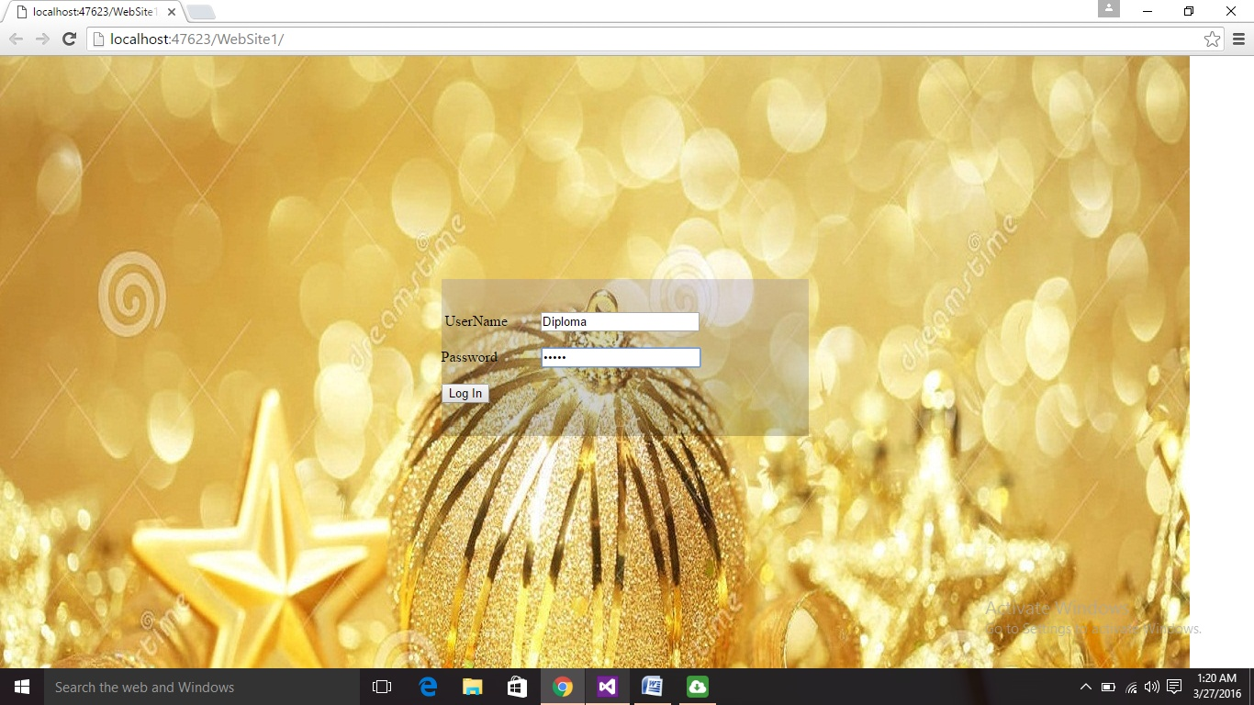

**STEP 2:-Home Page**

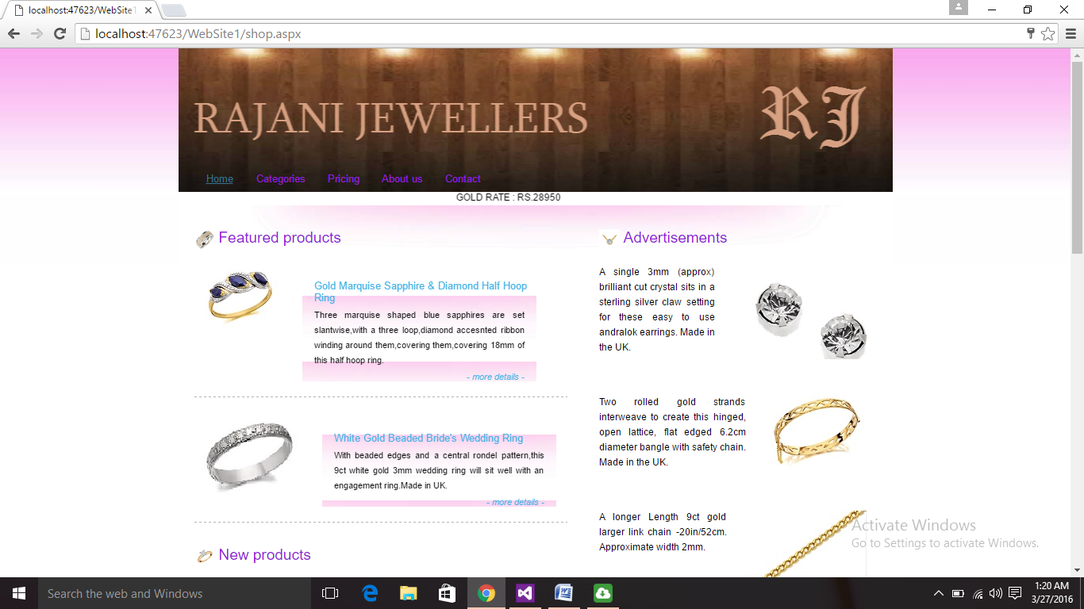

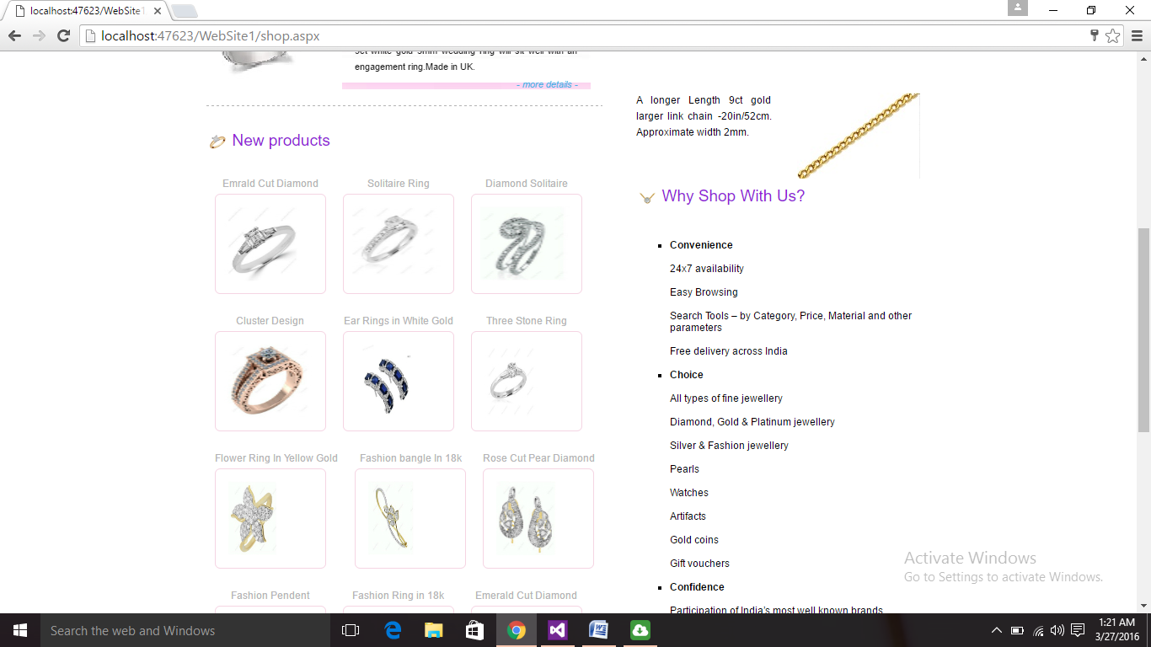

**STEP 3:-Categories**

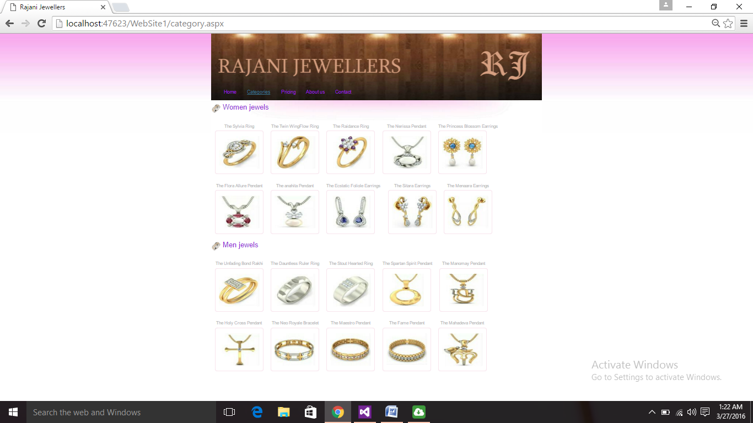

**STEP 4:- Select Any Product To View Its Details.**

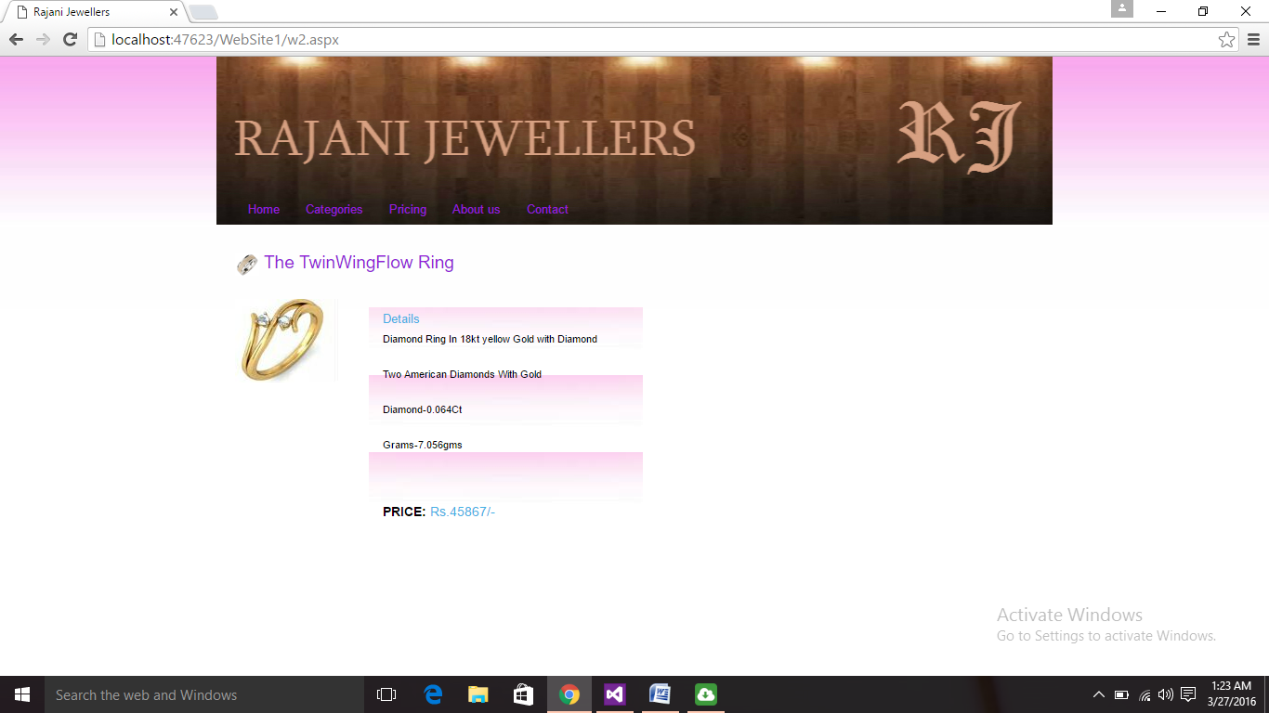

**STEP 5:-The Pricing Option**

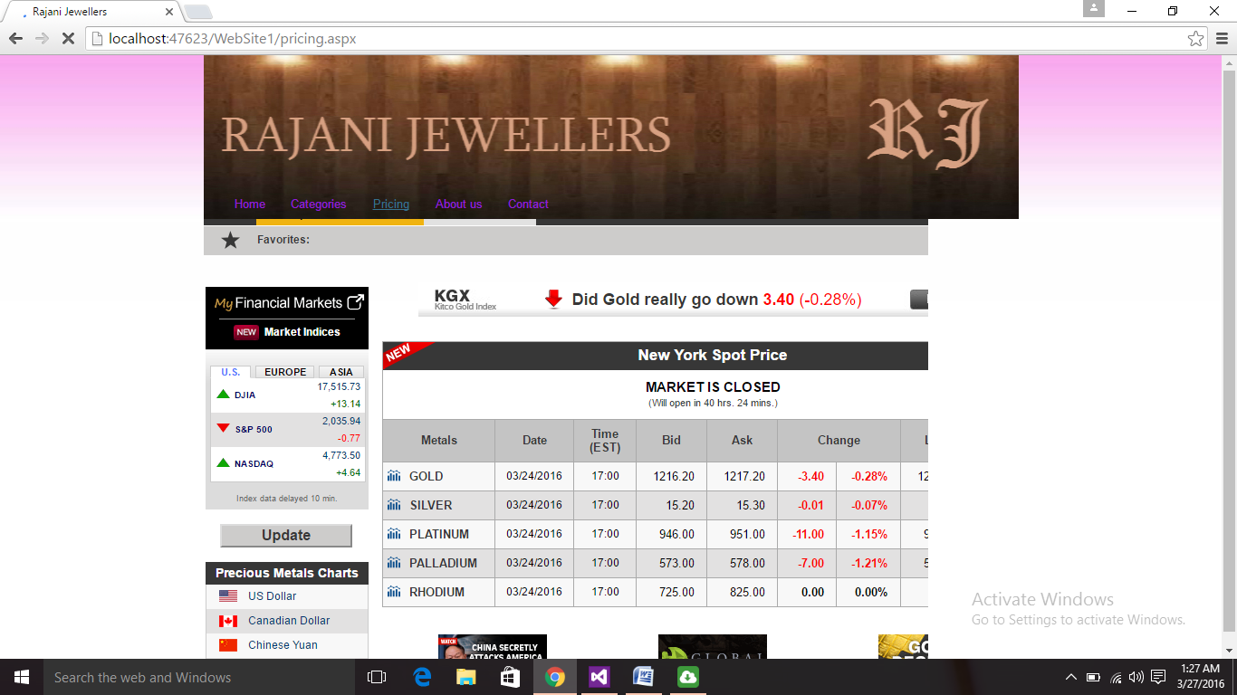

**STEP 6:-About us**

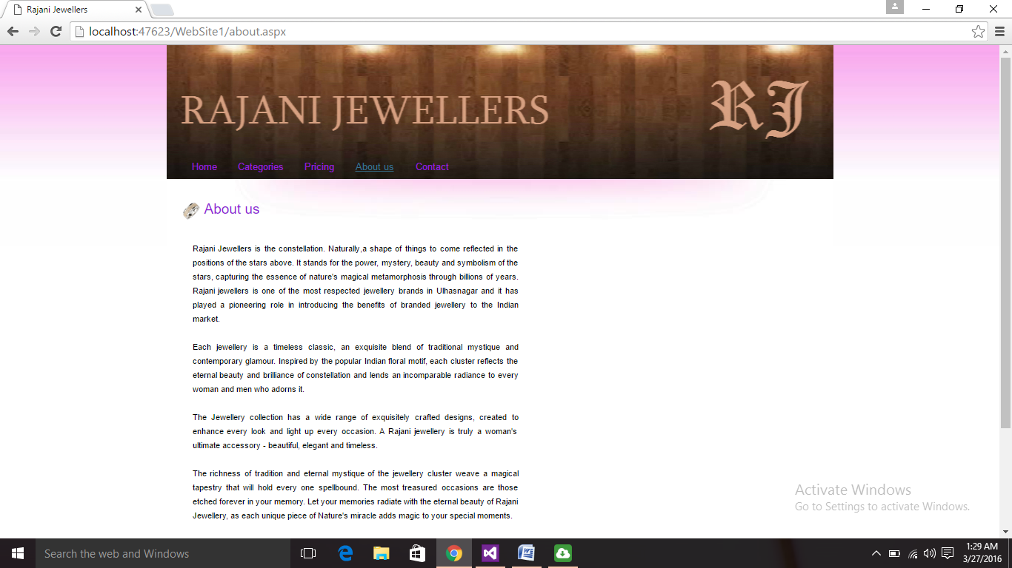

**CHAPTER 7:-**

**DATA FLOW DIAGRAMS**

**DFD LEVEL 0:**

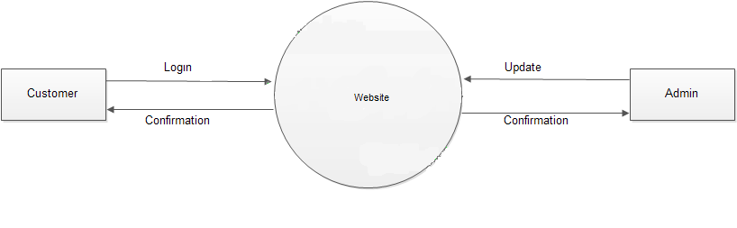

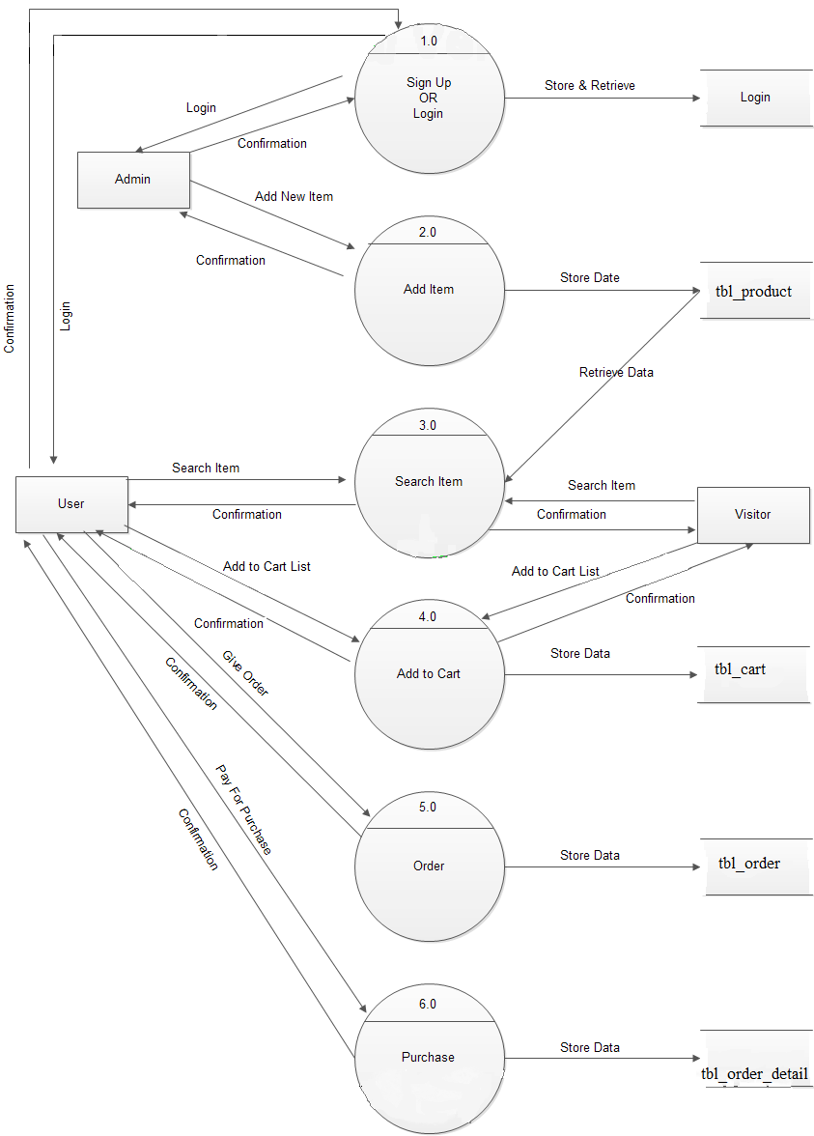

**DFD LEVEL 1:**

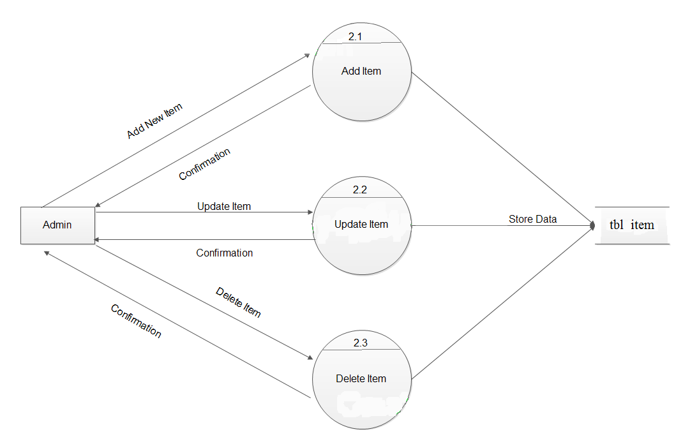

**DFD LEVEL 2:**

**Flow Chart:**

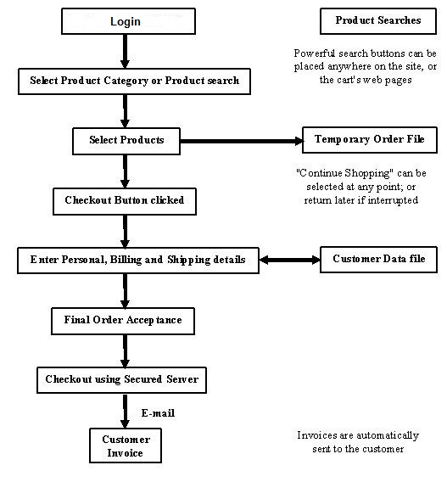

**CHAPTER 8**

**CONCLUSION**

* We conclude that we should manage purchasing the jewellery online without any hestitation.
* Each and every thing is made easy and simple for the people.
* We provide with the best online shopping jewellery website to the people.
* This is the secure website where information is not lost. Every new product is displayed here first.
* Everyday gold rate is updated.Everyday website is updated for the people.
* This website is For the people...

**CHAPTER 9**

**Bibliography/References**

**Books Refered:**

* Begining ASP.NET by Imar spaanjaars
* Professional ASP.NET by Jason N. Gaylord, Christian Wenz
* NIIT Books
* Pro ASP.NET by Matthew MacDonald

**References:**

* [www.youtube.com](http://www.youtube.com)
* [www.codeproject.com](http://www.codeproject.com)
* [www.msdn.com](http://www.msdn.com)
* [www.bigresource.com](http://www.bigresource.com)